Objectives
- I am looking forward for challenging working environment that will enable me fully utilized my capabilities and potentials.
- 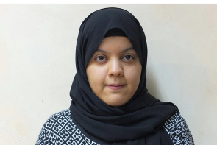I enjoy adding value to work experience new techniques in order to outperform my peers and be successful in my career.
Personal Information

- Date of Birth: June 25, 1996.
- Nationality: Bahraini.
- Place of residence: Bilad Al-Qadeem.
- Place of Birth: Jidhafs.
- Contact Number: (+973)33422025
- E-mail: a.aladraj@hotmail.com
- Languages: Arabic / English.
- Driving License: Driving license since 2015.

Education / Skills

- B.Sc in Accounting
University of Bahrain
To be Graduated 2019

- Commercial Secondary School Certificate
The Indian School Bahrain
Graduated 2014

Professional Experience

- KPMG
-Audit Department
(From 15 January to 28 February 2019)

I had experience at seven clients:
- NBB
- NFH
- Ossol Asset Management
- BDFS
- Khaleeji Commercial Bank
- BISB
- Ebrahim Khalil Kanoo

Responsibilities at clients
- Casting
- Minutes
- Vouching
- Credit Review
- Excel Skills
- Roll-forward
- Communicating with clients
- etc

Interests and activities
  - Willing to expert new majors
  - Scholiast with people
  - Very highly motivation and ambition
  - Willing to earn new information and knowledge
  - Very good Experience in computer
Willingness
  - Will give my best to the company.
  - Will quickly fit in with the company.
  - Will promote the company.
  - Will stay on and grow with the company.
  - Will be a tremendous benefit to the company.
  - I am extremely willing to work hard and under pressure.
  - I am willing to take up challenges.

Thank you for your valuable time,

